Two normal probability density functions  and . Where do they cross?

 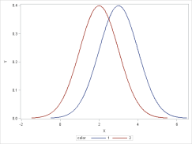





 (only if  in which case any X works)

OR…

  

If the variances are not equal then the algebra is slightly more complicated and the curves will cross in 2 places.

 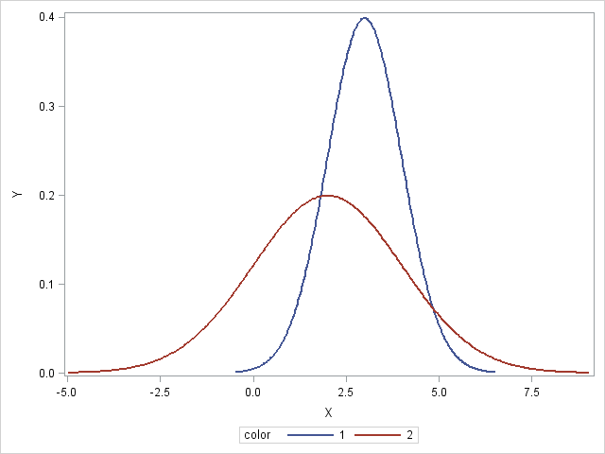





so we get the crossing points by solving aX2+bX+c=0 where

, , 

and since these quantities are all known when the means and variances are known we can easily compute the crossing points by solving the quadratic equation aX2+bX+c=0 .